Andre Hardy – Project 7-3

5. In the right pane, double-click Certificates to display the CAs approved for this computer. Scroll through this list. How many of these CAs have your heard of before?
A: I have not heard of most of these certs before this.

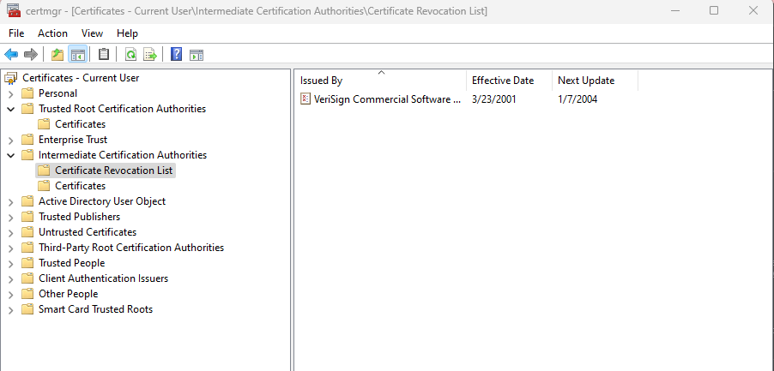

10. Read the information about the revoked certificate, and click fields for more detail, if necessary. Why do you think this certificate has been revoked? Close the Certificate Revocation List by clicking the Ok button.
A: I think this certificate gets revoked when it has been compromised.

